**Commitment to Child Safety**

*Avondale Primary School is committed to safety and wellbeing of all children and young people. This will be the primary focus of our care and decision making. Avondale Primary School has zero tolerance for child abuse.*

*Avondale Primary School is committed to providing a child safe environment where children and young people are safe, and their voices are heard about decisions that affect their lives. Particular attention will be paid to the cultural safety of Aboriginal children and children from culturally and / or linguistically diverse backgrounds, international students, vulnerable children as well as the safety of children with a disability.*

*Every person involved in Avondale Primary School has a responsibility to understand the important and specific role he/ she plays individually and collectively to ensure that the wellbeing and safety of all children and young people is at the forefront of all they do and every decision they make.*

**Purpose**

To ensure school staff understand their supervision and yard duty responsibilities.

**Help for non-English speakers**

If you need help to understand the information in this policy please contact the school office eon 9318 1755

**Scope**

The principal is responsible for ensuring that there is a well-organised and responsive system of supervision in place during school hours, before and after school, and on school excursions and camps.

This policy applies to all teaching and non-teaching staff at Avondale Primary School, including education support staff, casual relief teachers and visiting teachers.

**Policy**

Appropriate supervision is an important strategy to monitor student behaviour and enables staff to identify and respond to possible risks at school as they arise. It also plays a vital role in helping schools to discharge their duty of care to students.

The Principal is responsible for ensuring that there is a well organised and responsive system of supervision and yard duty in place during school hours, before and after school, and on school excursions and camps and other school activities.

School staff are responsible for following reasonable and lawful instructions from the Principal, including instructions to provide supervision to students at specific dates, times and places.

### **Before and after school**

Avondale Primary School’s grounds are supervised by school staff from 8.40am until 3.30pm. Outside of these hours, school staff will not be available to supervise students.

Parents and carers will be advised through a notification on our school website and assembly announcements, regular reminders in our newsletter and Compass posts that they should not allow their children to attend Avondale Primary School outside of these hours.

Before and after school, school staff will be available to supervise the school grounds from 8.40-8.50am and 3.15-3.30pm. Any students who have not been collected by their parents/carers by 3.30pm will be asked to wait in the office foyer.

If a student is not collected before supervision finishes at the end of the day, the principal or Student Wellbeing Coordinator will:

* attempt to contact the parents/carers
* attempt to contact the emergency contacts
* place the student in an out of school hours care program (if available)
* contact Victoria Police and/or the Department of Health and Human Services (Child Protection) to arrange for the supervision, care and protection of the student.

Families are encouraged to contact Sonya Coleman on 0405 529 972 or email [office@communityoshcservices.com](mailto:office@communityoshcservices.com) for more information about the before and after school care facilities available to our school community.

Students attending out of hours care will be supervised by Community OSHC program staff from 7.15-8.45am and 3.15-6.00pm. Students are not permitted to be in the yard unless supervised by a program staff member. Pupil free days supervision is available from 8:00am until 6:00pm.

If a student continuously arrives at school before supervision commences at the beginning of the day, the principal or Student Wellbeing Coordinator will, as soon as practicable, follow up with the parent/carer to:

* advise parent/carer of the supervision arrangements before school
* request that the parent/ carer make alternate arrangements.

If a student is not collected before supervision finishes at the end of the day on more than 5 occasions, the principal or Student Wellbeing Coordinator will:

* advise parent/carer of the supervision arrangements before school
* request that the parent/ carer make alternate arrangements.

School staff who are rostered on for before or after school supervision must follow the processes outlined below.

### **Yard duty**

All staff at Avondale Primary School are expected to assist with yard duty supervision and will be included in the weekly roster.

The Assistant Principal is responsible for preparing and communicating the yard duty roster on a regular basis. At Avondale Primary School, school staff will be designated a specific yard duty area to supervise.

The designated yard duty areas for our school as at Term 3, 2021 are

|  |  |
| --- | --- |
| **Zone** | **Area** |
| **Zone 1** | Oval |
| **Zone 2** | Playground and basketball court |
| **Zone 3** | Middle area between Building 1 & 2 |
| **Zone 4** | Front of school |

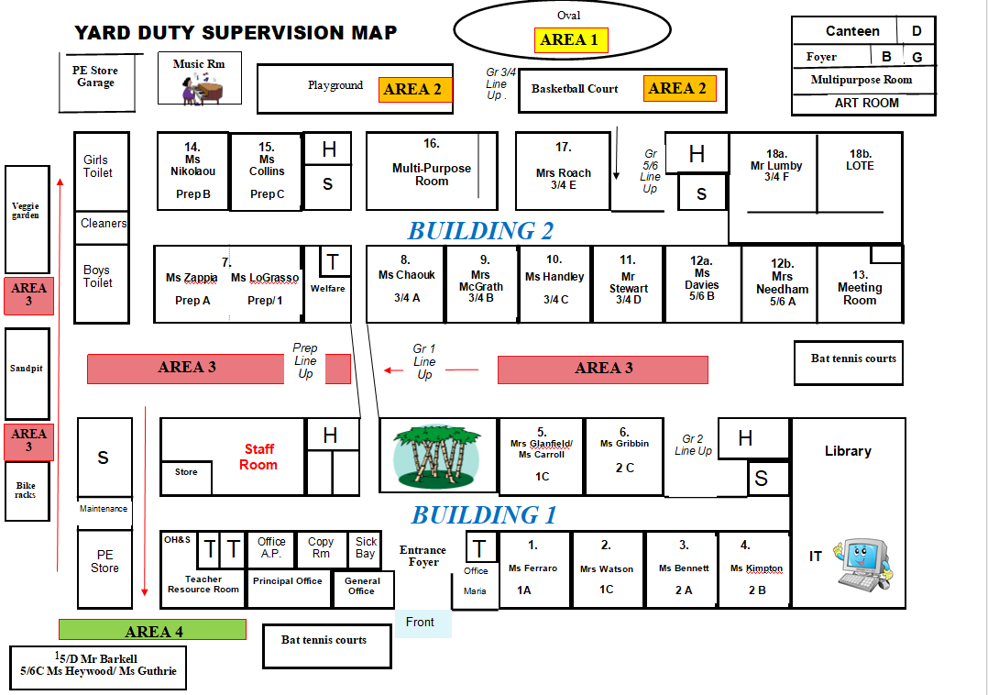

School staff must

Staff who are rostered for yard duty must

During yard duty, supervising staff must:

* wear a provided safety/hi-vis vest whilst on yard duty. Safety/hi-vis vests will be stored in the First Aid room
* remain in the designated area until they are replaced by a relieving teacher
* carry the designated yard duty first aid bag at all times during supervision. The yard duty first aid bag will be stored in First Aid room.
* methodically move around the designated zone to ensure that all areas are within line of sight to at least one yard duty teacher at a time
* be alert and vigilant
* carry a mobile phone to use in case of emergency
* be familiar with the yard duty bag information tags e.g. students with Epipens
* intervene immediately if potentially dangerous or inappropriate behaviour is observed in the yard
* enforce behavioural standards and implement appropriate consequences for breaches of safety rules, in accordance with any relevant disciplinary measures set out in the school’s *Student* *Engagement and Wellbeing* policy and *Behaviour Management Policy*
* ensure that students who require first aid assistance receive it as soon as practicable
* report any incidents or near misses as appropriate to classroom teachers and keep a record in their diary
* if being relieved of their yard duty shift by another staff member (for example, where the shift is ‘split’ into 2 consecutive time periods), ensure that a brief but adequate verbal ‘handover’ is given to the next staff member in relation to any issues which may have arisen during the first shift.

If the supervising staff member is unable to conduct yard duty at the designated time, they shouldcontact the Assistant Principalwith as much notice as possible prior to the relevant yard duty shiftto ensure that alternative arrangements are made.

If the supervising staff member needs to leave yard duty during the allocated time, they should contact the Principal or Assistant Principalbut should not leave the designated area until the relieving staff member has arrived in the designated area.

If a relieving or next staff member does not arrive for yard duty, the staff member currently on duty should send a message to the office and not leave the designated area until a replacement staff member has arrived.

Should students require assistance during recess or lunchtime, they are encouraged to speak to the supervising yard duty staff member.

### **Classroom**

The classroom teacher is responsible for the supervision of all students in their care during class.

If a teacher needs to leave the classroom unattended at any time during a lesson, they should first contact the classroom teacher next door or the office for assistance. The teacher should then wait until another staff member has arrived at the classroom to supervise the class prior to leaving.

### **School activities, camps and excursions**

The principal and leadership team are responsible for ensuring that students are appropriately supervised during all school activities, camps and excursions, including when external providers are engaged to conduct part or all of the activities. Appropriate supervision will be planned for special school activities, camps and excursions on an individual basis, depending on the activities to be undertaken and the level of potential risk involved.

## **Digital devices and virtual classroom**

Avondale Primary School follows the Department’s [Cybersafety and Responsible Use of Technologies Policy](https://www2.education.vic.gov.au/pal/cybersafety/policy) with respect to supervision of students using digital devices.

While parents are responsible for the appropriate supervision of students accessing virtual classrooms from home:

* student attendance will be monitored and recorded daily by classroom teachers
* any wellbeing or safety concerns for the student will be managed in accordance with our usual processes – refer to our Student Wellbeing and Engagement Policy and our Child Safety Responding and Reporting Policy and Procedures for further information.

## **Students requiring additional supervision support**

Sometimes students will require additional supervision, such as students with disability or other additional needs. In these cases, the Principal or delegate will ensure arrangements are made to roster additional staff as required. This may include on yard duty, in the classroom or during school activities.

## **Supervision of student in emergency operating environments**

In emergency circumstances our school will follow our Emergency Management Plan, including with respect to supervision.

In the event of any mandatory period of remote or flexible learning our School will follow the operations guidance issued by the Department.

**COMMUNICATION**

This policy will be communicated to our school community in the following ways:

* available on school website
* included in staff induction processes
* discussed at staff briefings or meetings, as required
* accessible to staff on Google Drive Online Staffroom
* included as a reference in our school newsletter each term
* made available in hard copy from school administration upon request

**Further Information and Resources**

* the Department’s Policy and Advisory Library (PAL):
  + [Child Safe Standards](https://www2.education.vic.gov.au/pal/child-safe-standards/policy)
  + [Cybersafety and Responsible Use of Technologies](https://www2.education.vic.gov.au/pal/cybersafety/policy)
  + [Duty of Care](https://www2.education.vic.gov.au/pal/duty-of-care/policy)
  + [Excursions](https://www2.education.vic.gov.au/pal/excursions/policy)
  + [Supervision of Students](https://www2.education.vic.gov.au/pal/supervision-students/policy)
  + [Visitors in Schools](https://www2.education.vic.gov.au/pal/visitors/policy)

**POLICY REVIEW AND APPROVAL**

|  |  |
| --- | --- |
| School Council consultation | 14th September 2021 |
| Approved by | Principal: Jill Benham |
| Next scheduled review date | 14th September 2022 |

This policy will also be updated if significant changes are made to school grounds that require a revision of Avondale Primary School’s yard duty and supervision arrangements.